- Create Databases
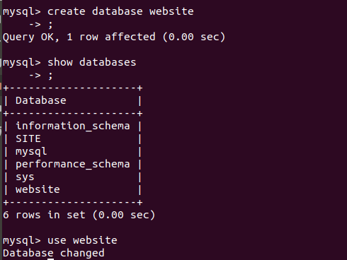

Q2. Design Schema

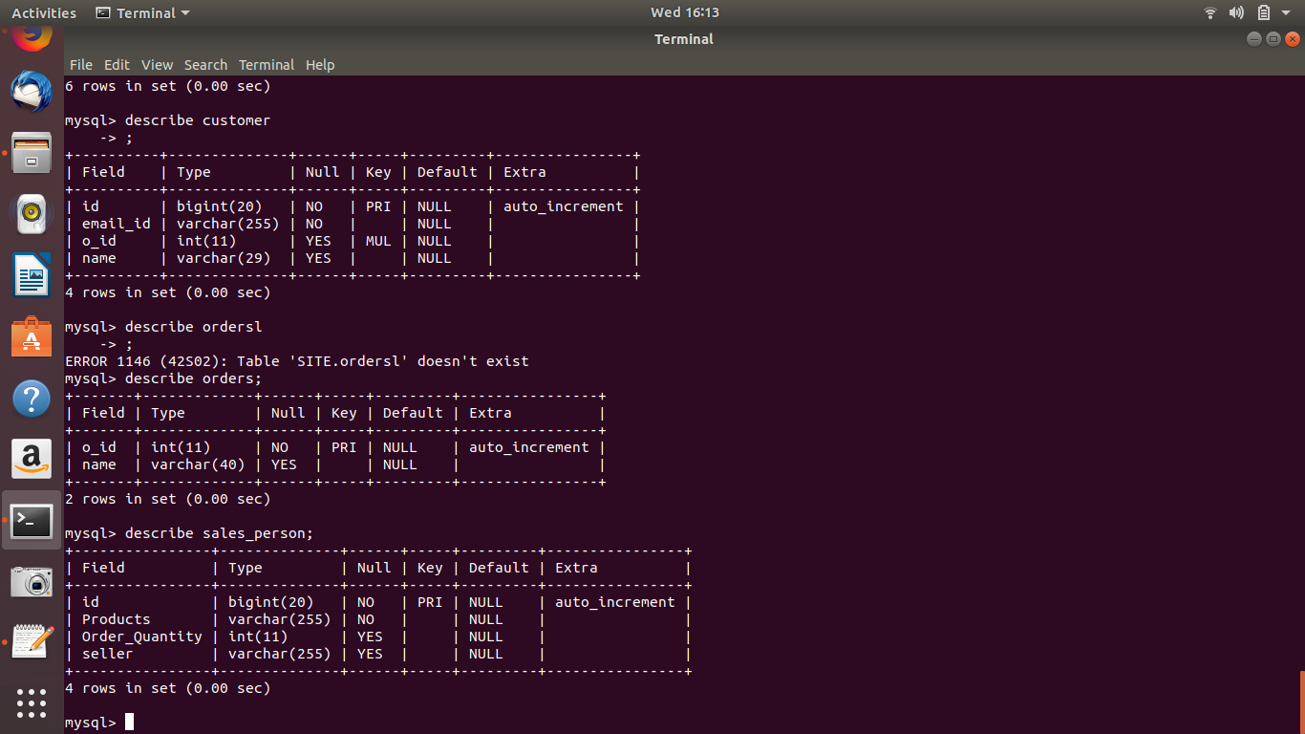

Q3. Create Table
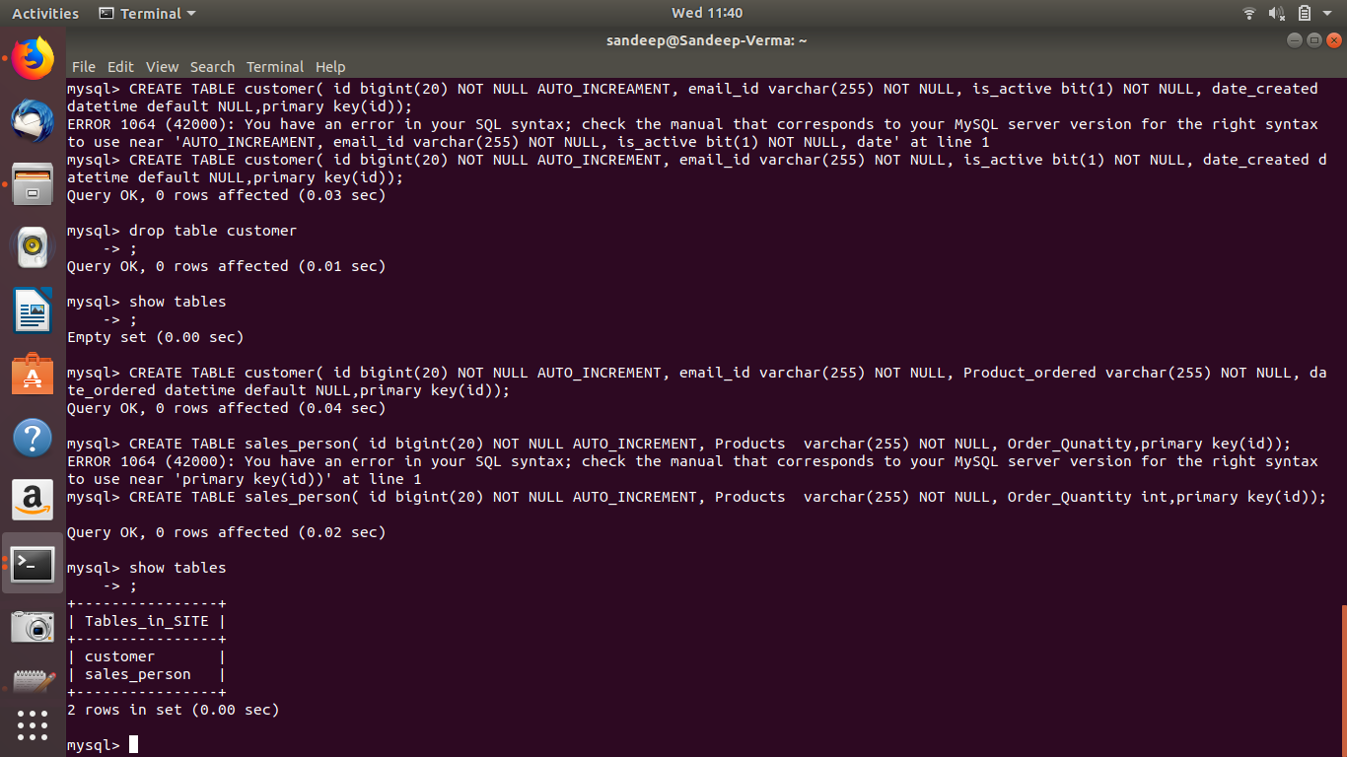
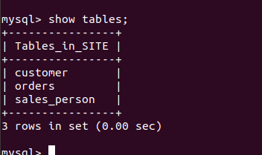

Q4. Insert sample data

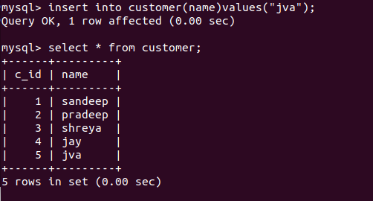

Q5. Find the sales person have multiple orders.
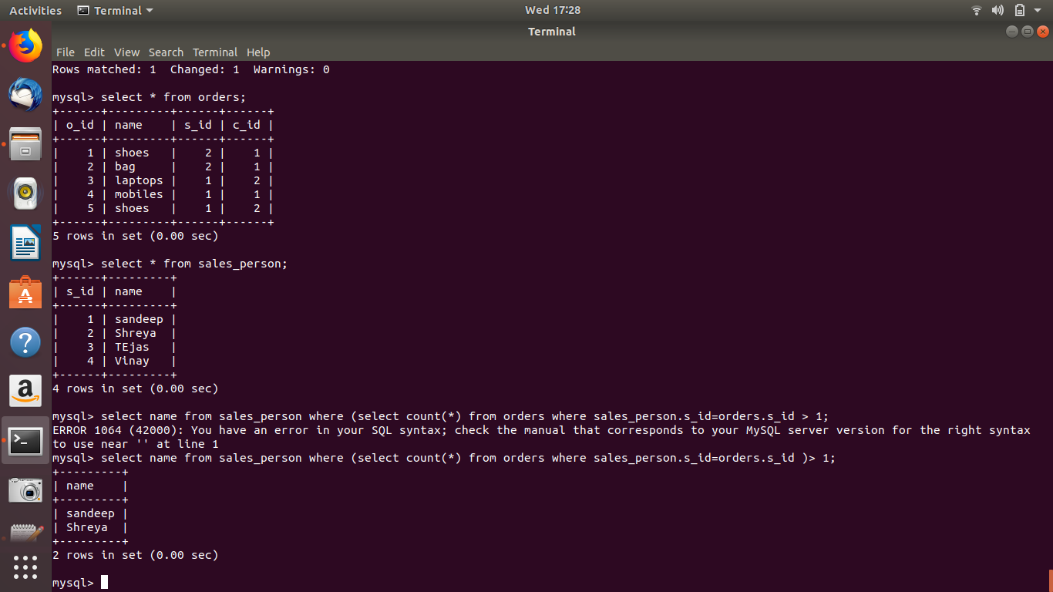

Q6. Find the all sales person details along with order details.
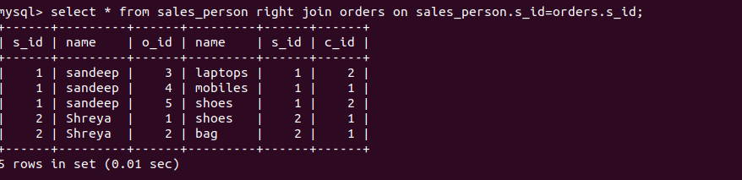

Q7. Create index

Q8. How to show index on a table.
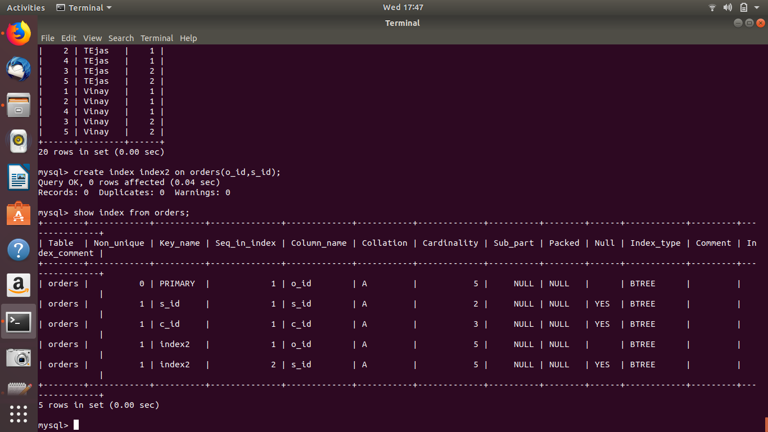
Q9. Find the order number, sale person name, along with the customer to whom that order belongs to
